Topalian
JavaScript
Filter
Functions
002
by
Christopher Andrew Topalian

All Rights Reserved
Copyright 2000-2024
Dedicated
to
God the Father

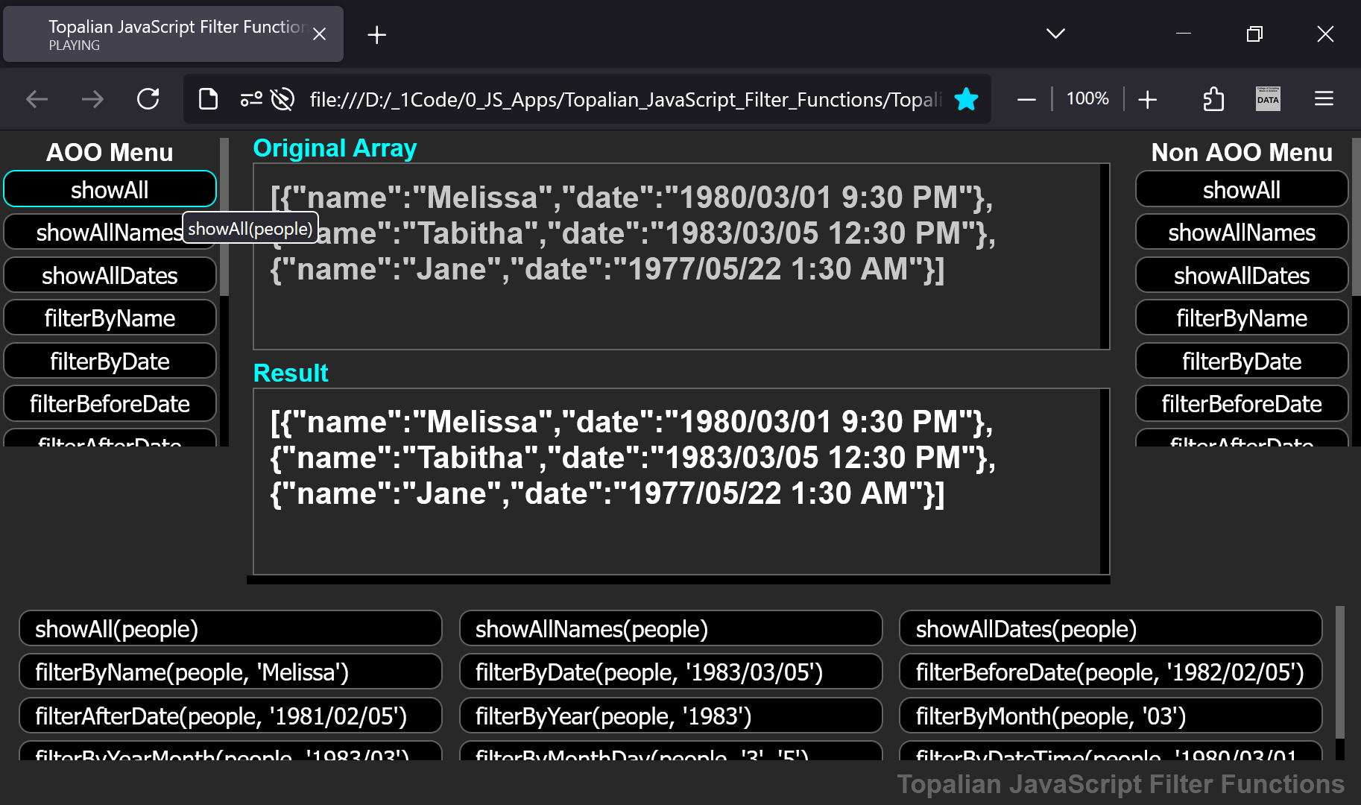

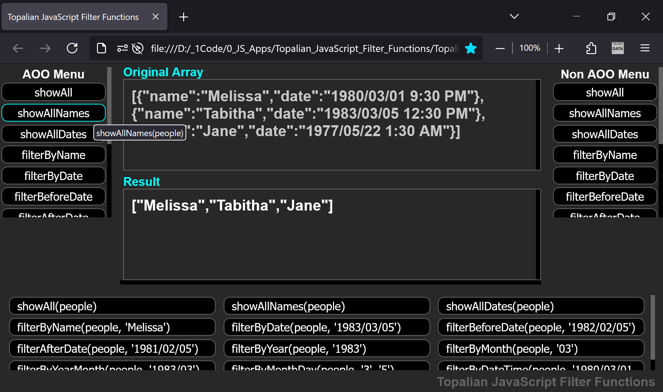

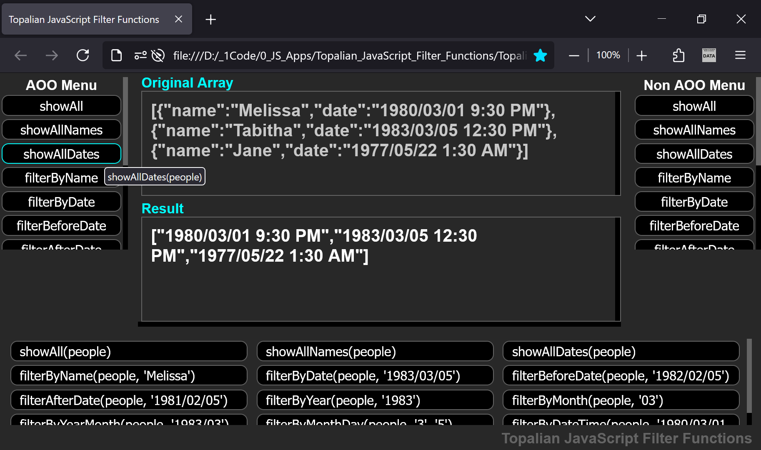

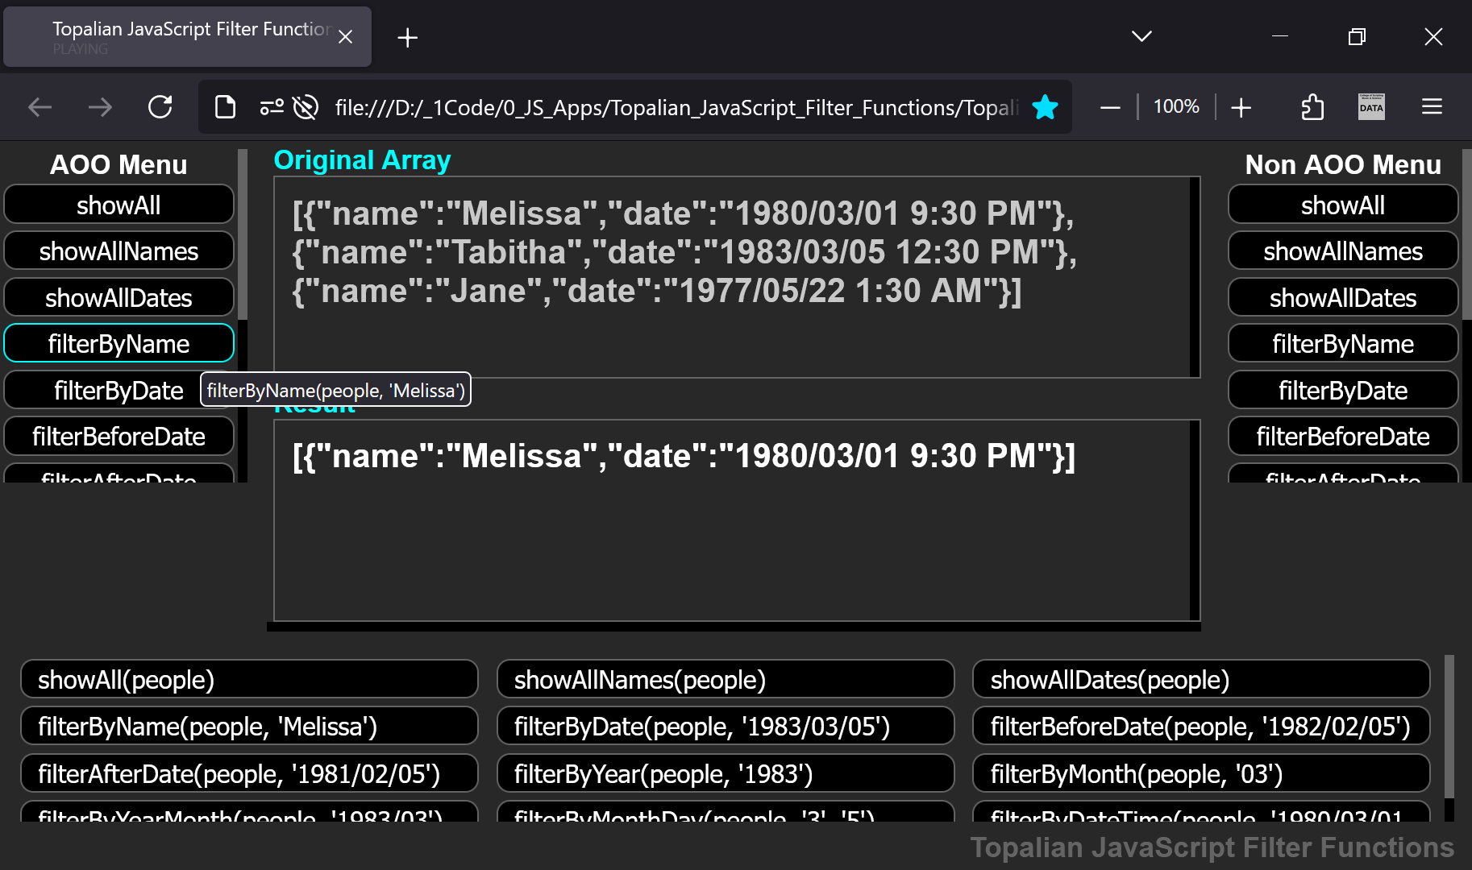

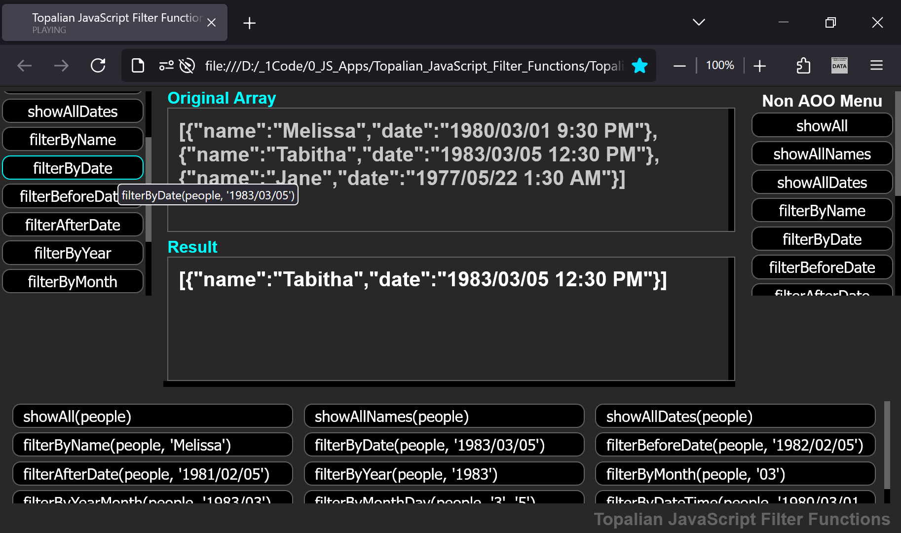

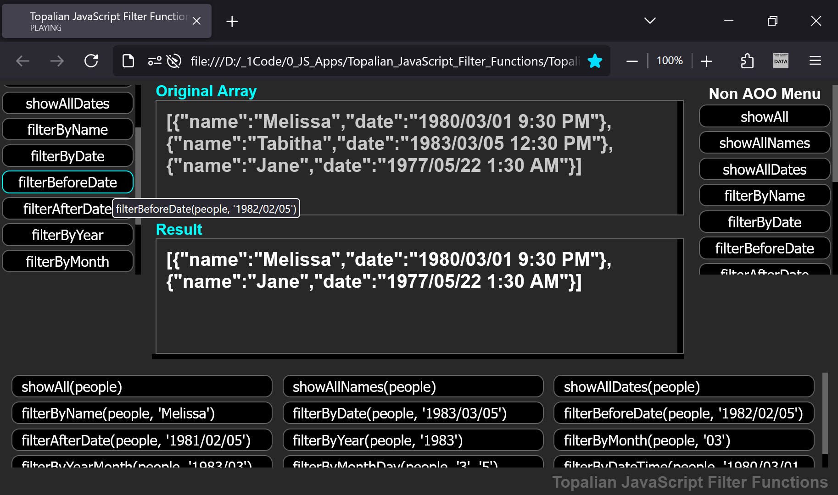

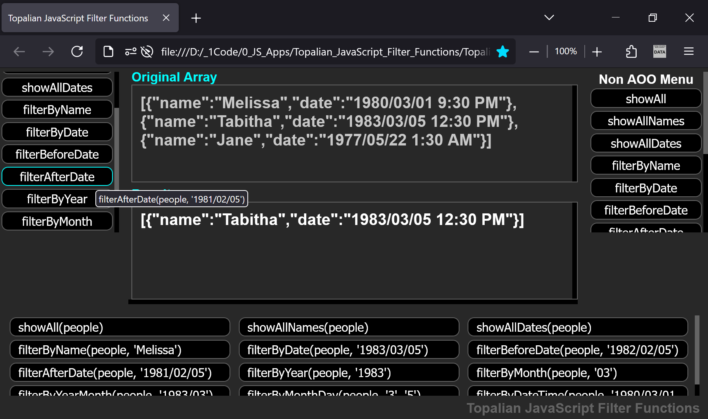

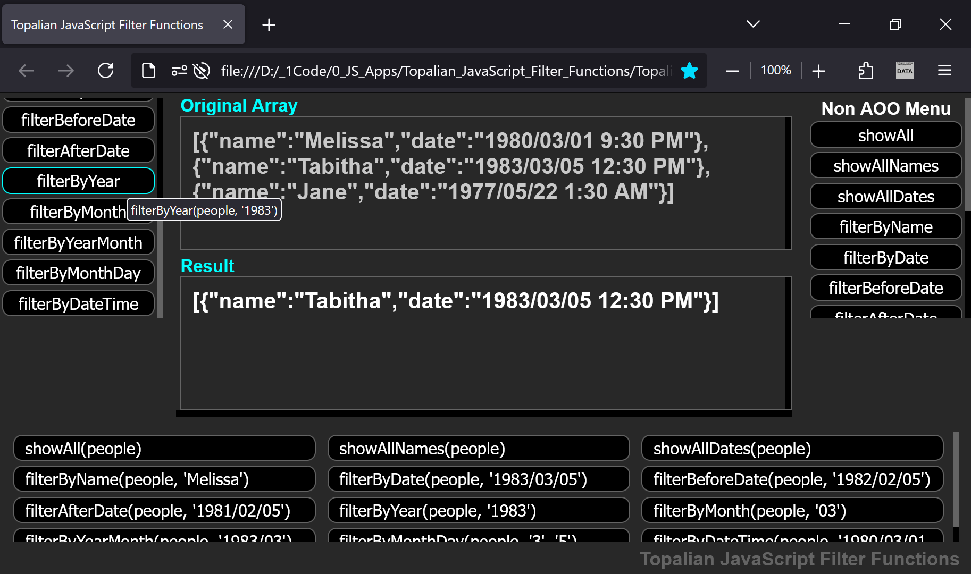

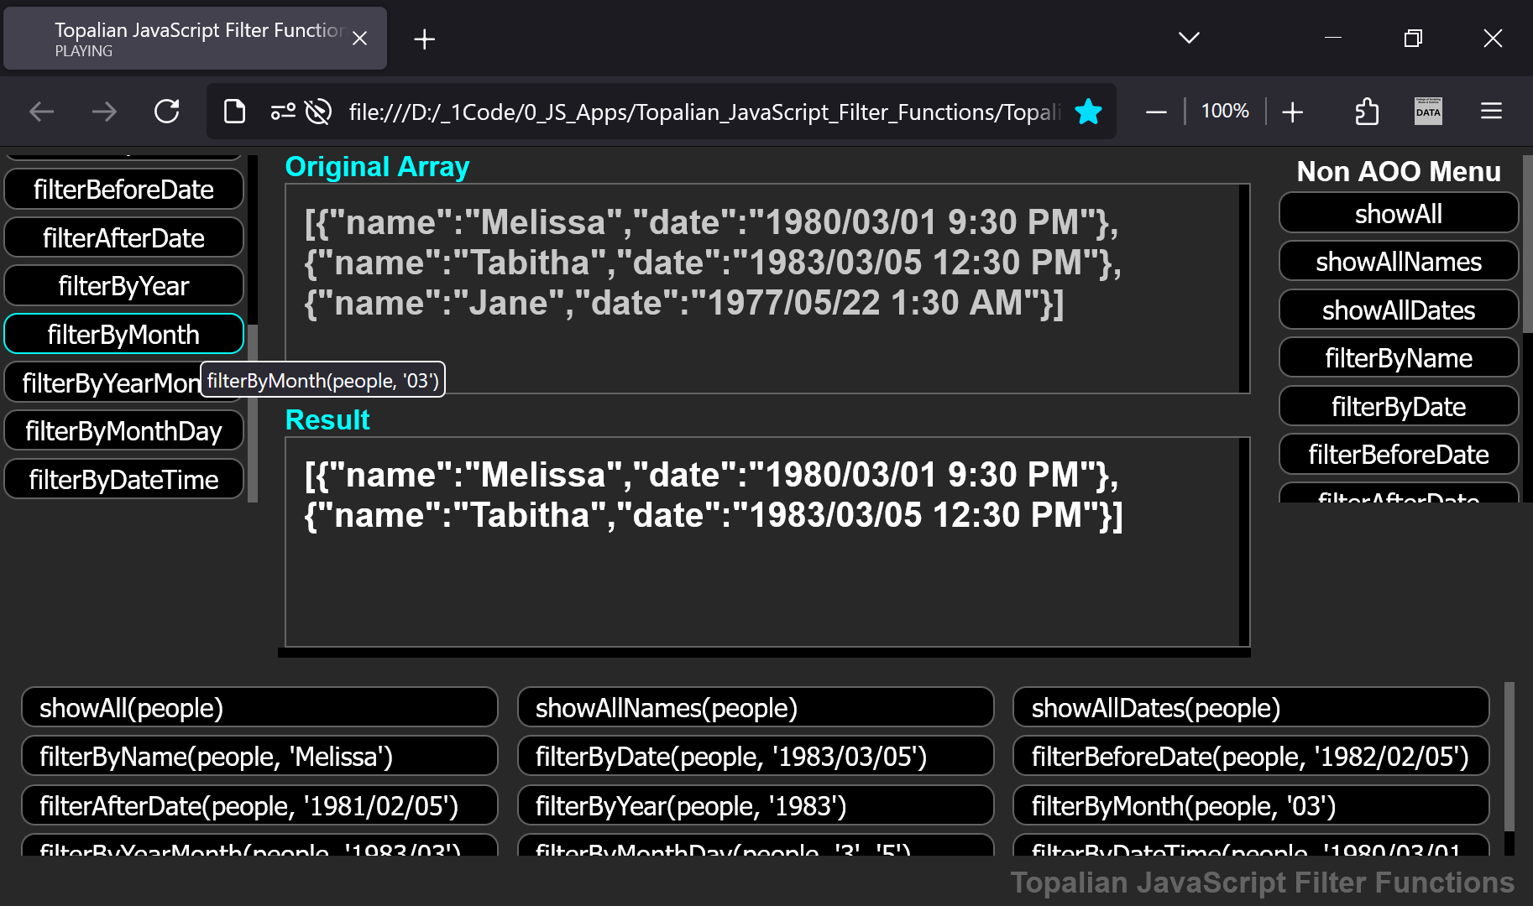

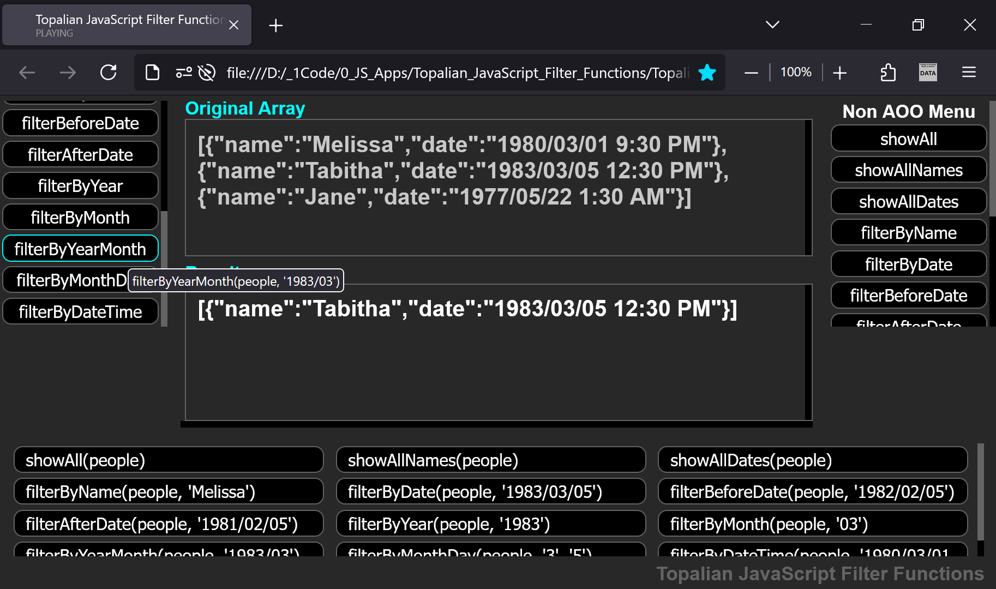

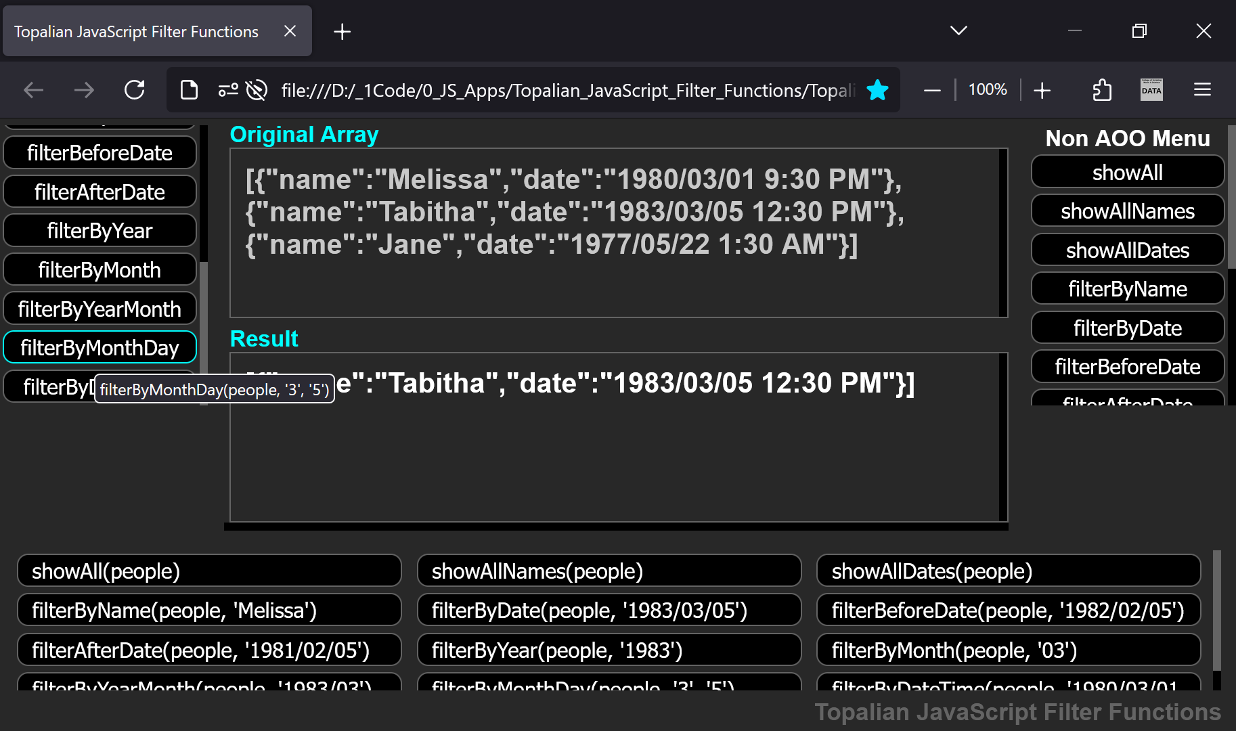

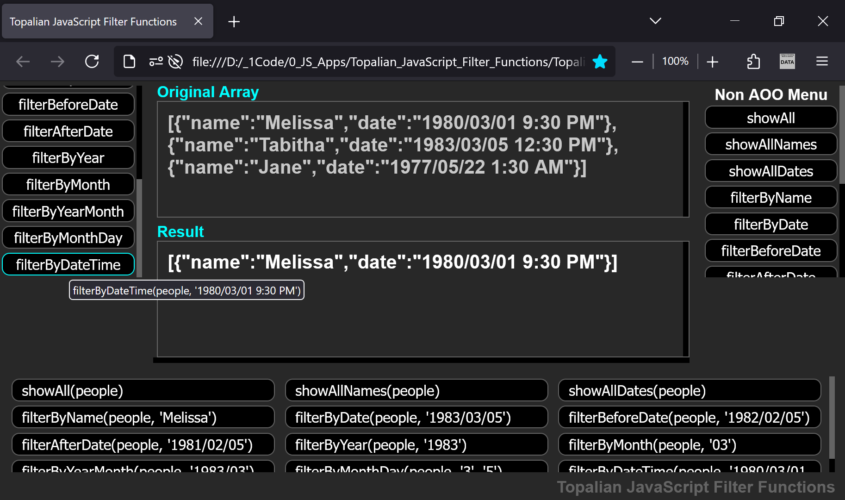

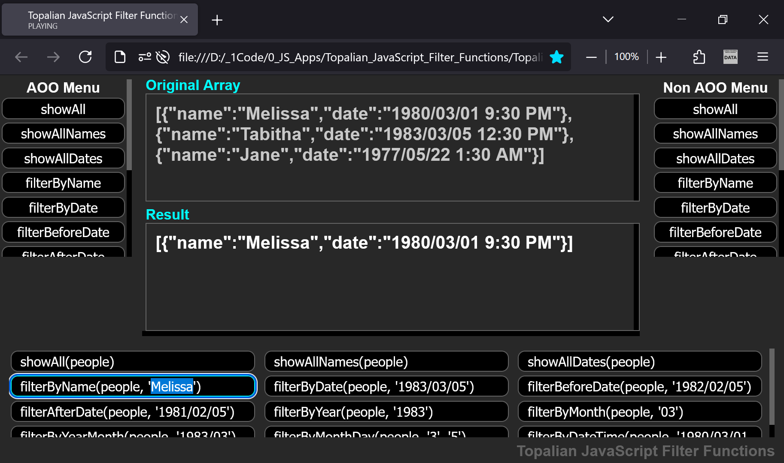

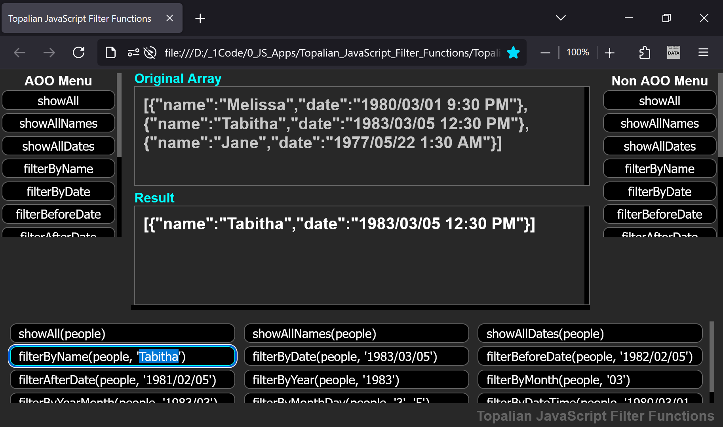

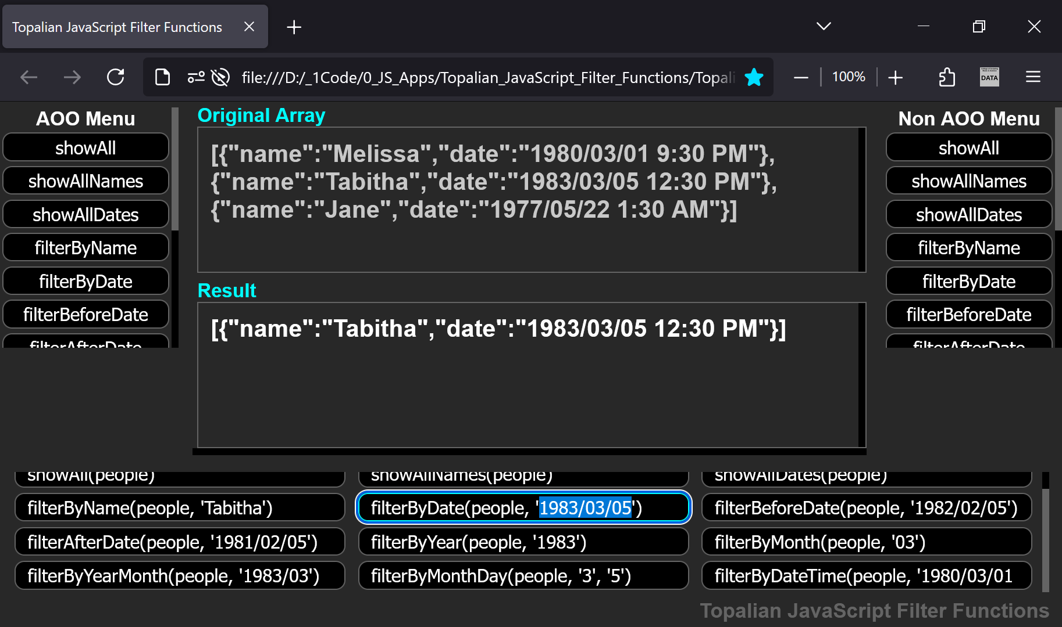

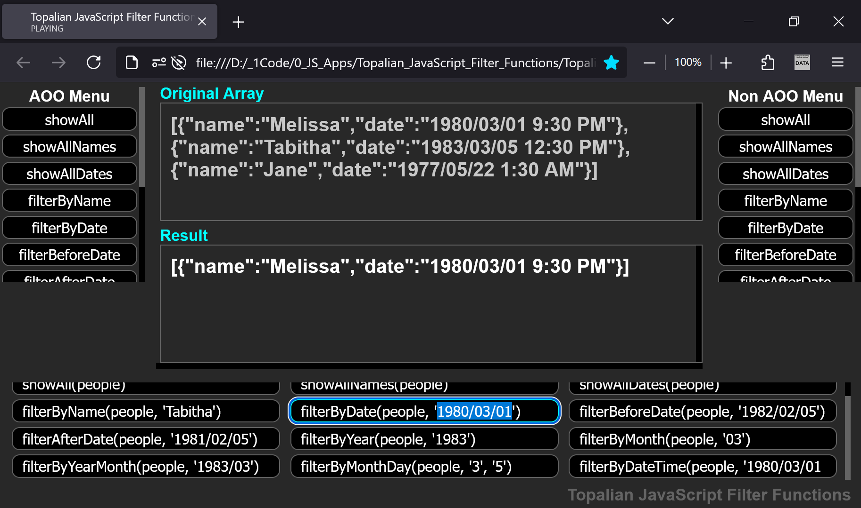
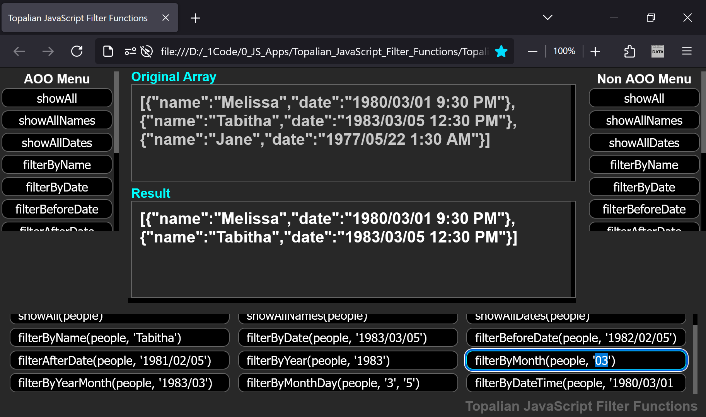

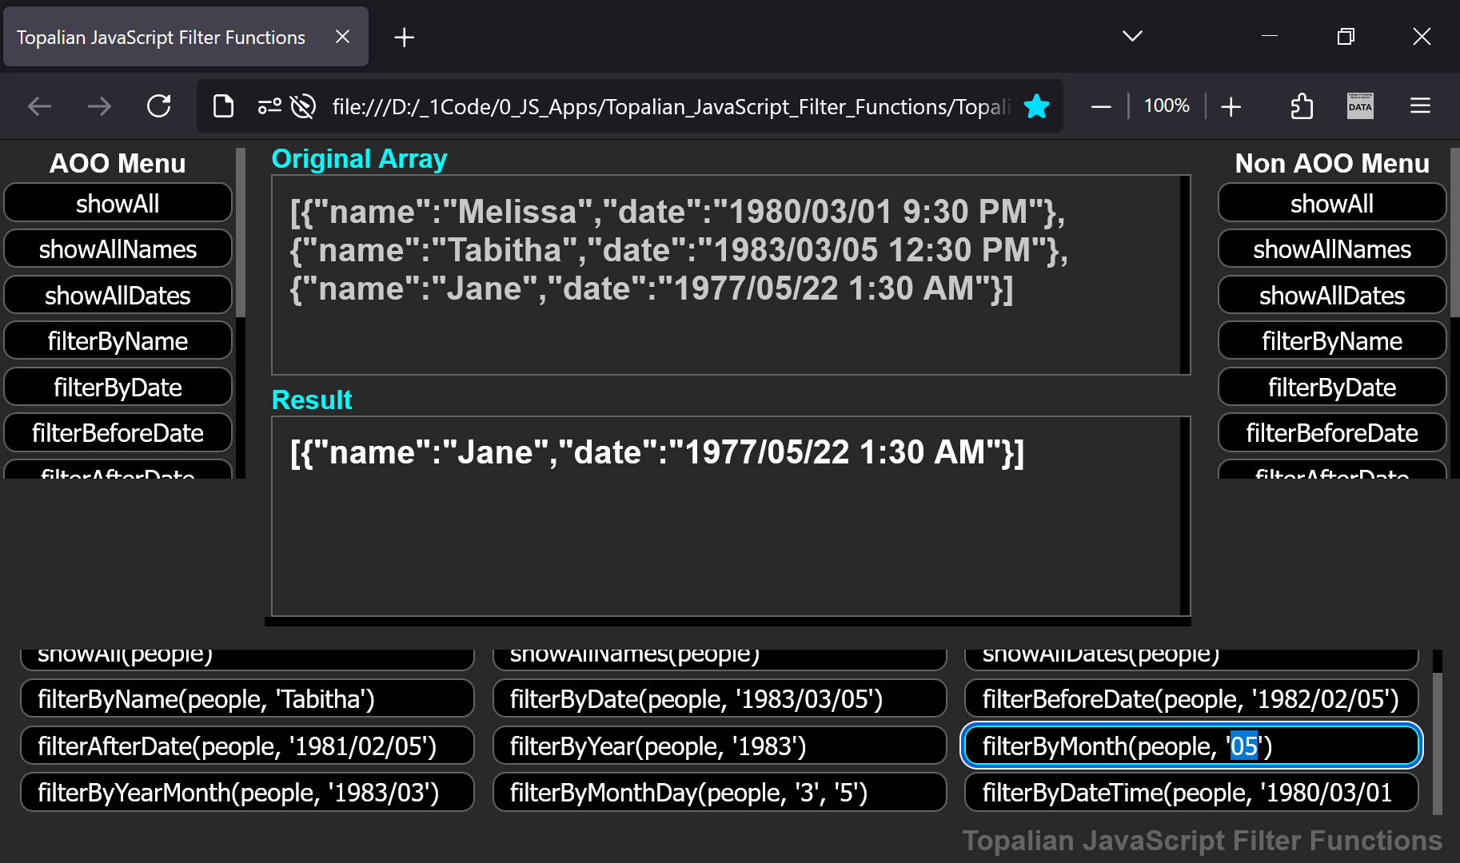
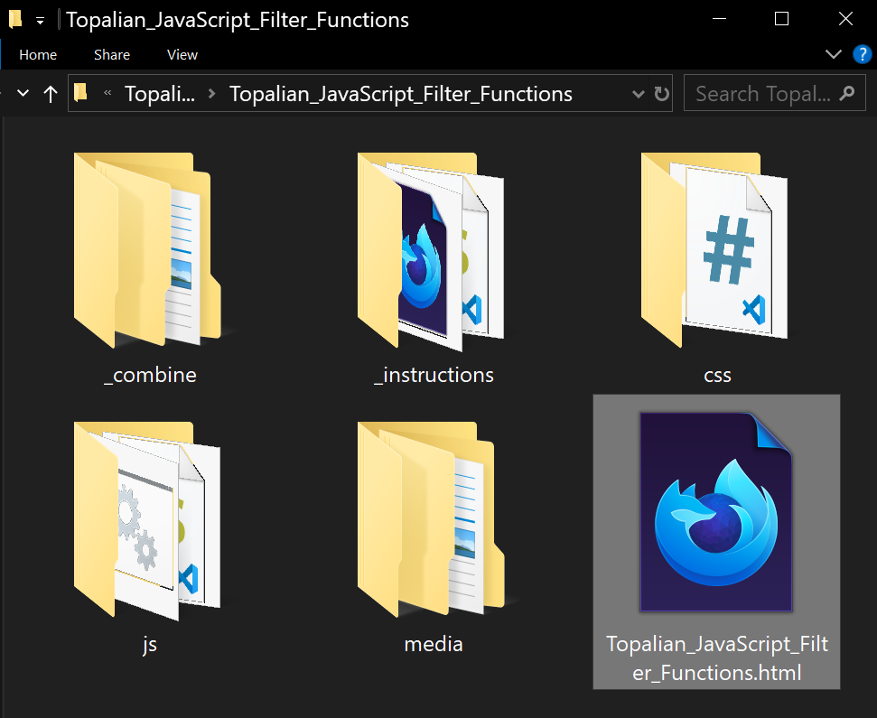
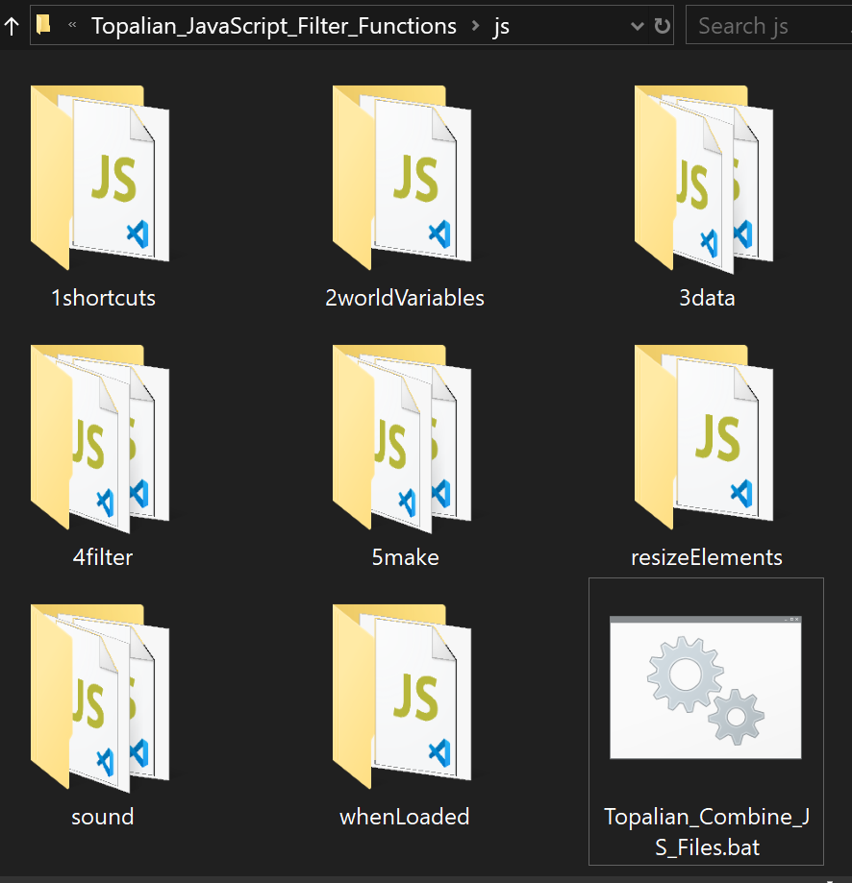
<!-- Dedicated to God the Father -->
<!-- All Rights Reserved Christopher Andrew Topalian Copyright 2000-2024 -->
<!-- https://github.com/ChristopherTopalian -->
<!-- https://github.com/ChristopherAndrewTopalian -->
<!-- Topalian_JavaScript_Filter_Functions.html -->
<!-- Version 002 - (2024-06-25) -->

<html>
<head>
<title> Topalian JavaScript Filter Functions </title>

<link rel = 'stylesheet' href = 'css/style001.css'>

<script src = 'js/1shortcuts/1shortcuts.js'></script>

<script src = 'js/2worldVariables/worldVariables.js'></script>

<script src = 'js/3data/people.js'></script>

<script src = 'js/3data/theFunctions.js'></script>

<script src = 'js/4filter/showAll.js'></script>

<script src = 'js/4filter/showAllNames.js'></script>

<script src = 'js/4filter/showAllDates.js'></script>

<script src = 'js/4filter/filterBeforeDate.js'></script>

<script src = 'js/4filter/filterAfterDate.js'></script>

<script src = 'js/4filter/filterByName.js'></script>

<script src = 'js/4filter/filterByDate.js'></script>

<script src = 'js/4filter/filterByYear.js'></script>

<script src = 'js/4filter/filterByMonth.js'></script>

<script src = 'js/4filter/filterByYearMonth.js'></script>

<script src = 'js/4filter/filterByMonthDay.js'></script>

<script src = 'js/4filter/filterByDateTime.js'></script>

<script src = 'js/5make/makeMenuLeft.js'></script>

<script src = 'js/5make/makeMenuRight.js'></script>

<script src = 'js/5make/makeInputs.js'></script>

<script src = 'js/5make/makeTitleOfApp.js'></script>

<script src = 'js/5make/makeCenterContainer.js'></script>

<script src = 'js/sound/sounds.js'></script>

<script src = 'js/sound/loadSounds.js'></script>

<script src = 'js/sound/audioPlay.js'></script>

<script src = 'js/whenLoaded/whenLoaded.js'></script>

<script src = 'js/resizeElements/resizeElements.js'></script>

</head>

<body onload = 'whenLoaded();'>

</body>

</html>

/* Dedicated to God the Father */
/* All Rights Reserved Christopher Andrew Topalian Copyright 2000-2024 */
/* https://github.com/ChristopherTopalian */
/* https://github.com/ChristopherAndrewTopalian */
/* style001.css */

body
{
background-color: rgb(40, 40, 40);
font-family: Arial;
font-size: 20px;
font-weight: bold;
color: rgb(255, 255, 255);
}

a
{
color: rgb(100, 100, 100);
text-decoration: none;
}

a:hover
{
text-decoration: underline;
}

input
{
width: 275px;
margin: 2px;
padding-left: 10px;
padding-right: 10px;
padding-top: 2px;
padding-bottom: 2px;
border: solid 1px rgb(100, 100, 100);
border-radius: 8px;
background-color: rgb(0, 0, 0);
font-size: 15px;
color: rgb(255, 255, 255);
cursor: pointer;
}

input:hover
{
border-color: rgb(0, 255, 255);
}

input:active
{
border-color: rgb(255, 0, 255);
}

.inputContainer
{
display: grid;
grid-template-columns: repeat(3, 1fr);
gap: 0.5px;
}

.buttonStyle001
{
width: 90hw;
margin: 2px;
padding-left: 10px;
padding-right: 10px;
padding-top: 2px;
padding-bottom: 2px;
border: solid 1px rgb(100, 100, 100);
border-radius: 8px;
background-color: rgb(0, 0, 0);
font-size: 15px;
color: rgb(255, 255, 255);
cursor: pointer;
box-sizing: border-box;
}

.buttonStyle001:hover
{
border-color: rgb(0, 255, 255);
}

.buttonStyle001:active
{
border-color: rgb(255, 0, 255);
}

#resultLabel
{
margin-left: 4px;
color: rgb(0, 255, 255);
}

#resultDiv
{
margin-left: 4px;
padding: 10px;
}

#originalArrayLabel
{
margin-left: 4px;
color: rgb(0, 255, 255);
}

#originalArrayDiv
{
margin-left: 4px;
padding: 10px;
color: rgb(200, 200, 200);
overflow-y: scroll;
}

* {
scrollbar-width: thin;
scrollbar-color: rgb(100, 100, 100) rgb(0, 0, 0);
}

// Dedicated to God the Father
// All Rights Reserved Christopher Andrew Topalian Copyright 2000-2024
// https://github.com/ChristopherTopalian
// https://github.com/ChristopherAndrewTopalian
// shortcuts.js

function ge(whichId)
{
let result = document.getElementById(whichId);
return result;
}

function ce(whichType)
{
let result = document.createElement(whichType);
return result;
}

function ba(whichElement)
{
let result = document.body.append(whichElement);
return result;
}

// Dedicated to God the Father
// All Rights Reserved Christopher Andrew Topalian Copyright 2000-2024
// https://github.com/ChristopherTopalian
// https://github.com/ChristopherAndrewTopalian
// worldVariables.js

let online = false;

// Dedicated to God the Father
// All Rights Reserved Christopher Andrew Topalian Copyright 2000-2024
// https://github.com/ChristopherTopalian
// https://github.com/ChristopherAndrewTopalian
// people.js

let people =
[
{
name: 'Melissa',
date: '1980/03/01 9:30 PM',
},

{
name: 'Tabitha',
date: '1983/03/05 12:30 PM'
},

{
name: 'Jane',
date: '1977/05/22 1:30 AM'
}
];

// Dedicated to God the Father
// All Rights Reserved Christopher Andrew Topalian Copyright 2000-2024
// https://github.com/ChristopherTopalian
// https://github.com/ChristopherAndrewTopalian
// theFunctions.js

let theFunctions =
[
{
name: `showAll`,
functionName: `showAll(people)`,
},

{
name: `showAllNames`,
functionName: `showAllNames(people)`,
},

{
name: `showAllDates`,
functionName: `showAllDates(people)`,
},

{
name: `filterByName`,
functionName: `filterByName(people, 'Melissa')`,
},

{
name: `filterByDate`,
functionName: `filterByDate(people, '1983/03/05')`,
},

{
name: `filterBeforeDate`,
functionName: `filterBeforeDate(people, '1982/02/05')`,
},

{
name: `filterAfterDate`,
functionName: `filterAfterDate(people, '1981/02/05')`,
},

{
name: `filterByYear`,
functionName: `filterByYear(people, '1983')`,
},

{
name: `filterByMonth`,
functionName: `filterByMonth(people, '03')`,
},

{
name: `filterByYearMonth`,
functionName: `filterByYearMonth(people, '1983/03')`,
},

{
name: `filterByMonthDay`,
functionName: `filterByMonthDay(people, '3', '5')`,
},

{
name: `filterByDateTime`,
functionName: `filterByDateTime(people, '1980/03/01 9:30 PM')`,
},
];

// Dedicated to God the Father
// All Rights Reserved Christopher Andrew Topalian Copyright 2000-2024
// https://github.com/ChristopherTopalian
// https://github.com/ChristopherAndrewTopalian
// filterAfterDate.js

function filterAfterDate(whichArray, whichDate)
{
let result = [];

for (let z = 0; z < whichArray.length; z++)
{
if (whichArray[z].date > whichDate)
{
result.push(whichArray[z]);
}
}

return result;
}

// Dedicated to God the Father
// All Rights Reserved Christopher Andrew Topalian Copyright 2000-2024
// https://github.com/ChristopherTopalian
// https://github.com/ChristopherAndrewTopalian
// filterBeforeDate.js

function filterBeforeDate(whichArray, whichDate)
{
let result = [];

for (let z = 0; z < whichArray.length; z++)
{
if (whichArray[z].date < whichDate)
{
result.push(whichArray[z]);
}
}

return result;
}

// Dedicated to God the Father
// All Rights Reserved Christopher Andrew Topalian Copyright 2000-2024
// https://github.com/ChristopherTopalian
// https://github.com/ChristopherAndrewTopalian
// filterByDate.js

function filterByDate(whichArray, whichDate)
{
let result = [];

for (let z = 0; z < whichArray.length; z++)
{
let parts = whichArray[z].date.split(' ');

if (parts[0] === whichDate)
{
result.push(whichArray[z]);
}
}

return result;
}

// Dedicated to God the Father
// All Rights Reserved Christopher Andrew Topalian Copyright 2000-2024
// https://github.com/ChristopherTopalian
// https://github.com/ChristopherAndrewTopalian
// filterByDateTime.js

function filterByDateTime(whichArray, whichDate)
{
let result = [];

for (let z = 0; z < whichArray.length; z++)
{
if (whichArray[z].date === whichDate)
{
result.push(whichArray[z]);
}
}

return result;
}

// Dedicated to God the Father
// All Rights Reserved Christopher Andrew Topalian Copyright 2000-2024
// https://github.com/ChristopherTopalian
// https://github.com/ChristopherAndrewTopalian
// filterByMonth.js

function filterByMonth(whichArray, whichMonth)
{
let result = [];

for (let z = 0; z < whichArray.length; z++)
{
let parts = whichArray[z].date.split('/');

if (parts[1] === whichMonth)
{
result.push(whichArray[z]);
}
}

return result;
}

// Dedicated to God the Father
// All Rights Reserved Christopher Andrew Topalian Copyright 2000-2024
// https://github.com/ChristopherTopalian
// https://github.com/ChristopherAndrewTopalian
// filterByMonthDay.js

function filterByMonthDay(whichArray, whichMonth, whichDay)
{
let result = [];

for (let z = 0; z < whichArray.length; z++)
{
let parts = whichArray[z].date.split(' ');

let datePart = parts[0];

let month = datePart.substring(5, 7);

let day = datePart.substring(8, 10);

if (whichMonth.length === 1)
{
whichMonth = '0' + whichMonth;
}
if (whichDay.length === 1)
{
whichDay = '0' + whichDay;
}

if (month === whichMonth && day === whichDay)
{
result.push(whichArray[z]);
}
}

return result;
}

// Dedicated to God the Father
// All Rights Reserved Christopher Andrew Topalian Copyright 2000-2024
// https://github.com/ChristopherTopalian
// https://github.com/ChristopherAndrewTopalian
// filterByName.js

function filterByName(whichArray, whichName)
{
let result = [];

for (let z = 0; z < whichArray.length; z++)
{
if (whichArray[z].name === whichName)
{
result.push(whichArray[z]);
}
}

return result;
}

// Dedicated to God the Father
// All Rights Reserved Christopher Andrew Topalian Copyright 2000-2024
// https://github.com/ChristopherTopalian
// https://github.com/ChristopherAndrewTopalian
// filterByYear.js

function filterByYear(whichArray, whichYear)
{
let result = [];

for (let z = 0; z < whichArray.length; z++)
{
if (whichArray[z].date.startsWith(whichYear))
{
result.push(whichArray[z]);
}
}

return result;
}

// Dedicated to God the Father
// All Rights Reserved Christopher Andrew Topalian Copyright 2000-2024
// https://github.com/ChristopherTopalian
// https://github.com/ChristopherAndrewTopalian
// filterByYearMonth.js

function filterByYearMonth(whichArray, whichYearMonth)
{
let result = [];

for (let z = 0; z < whichArray.length; z++)
{
if (whichArray[z].date.startsWith(whichYearMonth))
{
result.push(whichArray[z]);
}
}

return result;
}

// Dedicated to God the Father
// All Rights Reserved Christopher Andrew Topalian Copyright 2000-2024
// https://github.com/ChristopherTopalian
// https://github.com/ChristopherAndrewTopalian
// showAll.js

function showAll(whichArray)
{
let result = [];

for (let z = 0; z < whichArray.length; z++)
{
result.push(whichArray[z]);
}

return result;
}

// Dedicated to God the Father
// All Rights Reserved Christopher Andrew Topalian Copyright 2000-2024
// https://github.com/ChristopherTopalian
// https://github.com/ChristopherAndrewTopalian
// showAllDates.js

function showAllDates(whichArray)
{
let result = [];

for (let z = 0; z < whichArray.length; z++)
{
result.push(whichArray[z].date);
}

return result;
}

// Dedicated to God the Father
// All Rights Reserved Christopher Andrew Topalian Copyright 2000-2024
// https://github.com/ChristopherTopalian
// https://github.com/ChristopherAndrewTopalian
// showAllNames.js

function showAllNames(whichArray)
{
let result = [];

for (let z = 0; z < whichArray.length; z++)
{
result.push(whichArray[z].name);
}

return result;
}

// Dedicated to God the Father
// All Rights Reserved Christopher Andrew Topalian Copyright 2000-2024
// https://github.com/ChristopherTopalian
// https://github.com/ChristopherAndrewTopalian
// makeCenterContainer.js

function makeCenterContainer()
{
// centerContainer
let centerContainer = ce('div');
centerContainer.id = 'centerContainer';
centerContainer.style.position = 'fixed';
centerContainer.style.left = ge('leftMenu_buttonsContainer').style.right + 160 + 'px';
centerContainer.style.top = '2px';
centerContainer.style.overflowX = 'scroll';
ba(centerContainer);

//-//

// originalArrayLabel
let originalArrayLabel = ce('div');
originalArrayLabel.id = 'originalArrayLabel';
originalArrayLabel.textContent = 'Original Array';
originalArrayLabel.style.fontSize = '16px';
centerContainer.append(originalArrayLabel);

//-//

// originalArrayDiv
let originalArrayDiv = ce('div');
originalArrayDiv.id = 'originalArrayDiv';
originalArrayDiv.textContent = JSON.stringify(people);
originalArrayDiv.style.width = '450px';
originalArrayDiv.style.height = '100px';
originalArrayDiv.style.border = 'solid 1px rgb(100, 100, 100)';
originalArrayDiv.style.overflowY = 'scroll';
centerContainer.append(originalArrayDiv);

//-//

let hr001 = ce('br');
hr001.style.lineHeight = '5px';
centerContainer.append(hr001);

//-//

// resultLabel
let resultLabel = ce('div');
resultLabel.id = 'resultLabel';
resultLabel.textContent = 'Result';
resultLabel.style.fontSize = '16px';
centerContainer.append(resultLabel);

//-//

// resultDiv
let resultDiv = ce('div');
resultDiv.id = 'resultDiv';
resultDiv.textContent = 'Result';
resultDiv.style.width = '450px';
resultDiv.style.height = '100px';
resultDiv.style.border = 'solid 1px rgb(100, 100, 100)';
resultDiv.style.overflowY = 'scroll';
centerContainer.append(resultDiv);
}

// Dedicated to God the Father
// All Rights Reserved Christopher Andrew Topalian Copyright 2000-2024
// https://github.com/ChristopherTopalian
// https://github.com/ChristopherAndrewTopalian
// makeInputs.js

function makeInputs(whichArray)
{
// inputContainer
let inputContainer = ce('div');
inputContainer.id = 'inputContainer';
inputContainer.className = 'inputContainer';
inputContainer.style.position = 'fixed';
inputContainer.style.left = '10px';
inputContainer.style.top = ge('resultDiv').getBoundingClientRect().bottom + 20 + 'px';
inputContainer.style.height = '100px';
inputContainer.style.overflowY = 'scroll';
inputContainer.style.zIndex = 2;
ba(inputContainer);

//-//

for (let x = 0; x < whichArray.length; x++)
{
let theInput = ce('input');
theInput.id = whichArray[x].name;
theInput.value = whichArray[x].functionName;
theInput.onkeyup = function()
{
audioPlay('sfx_blip_001', 1.0);

ge('resultDiv').innerHTML = JSON.stringify(eval(theInput.value));
};
theInput.onmouseover = function()
{
audioPlay('sfx_warp_001', 1.0);
};
theInput.onclick = function()
{
audioPlay('sfx_blip_001', 1.0);

ge('resultDiv').innerHTML = JSON.stringify(eval(theInput.value));
};
inputContainer.append(theInput);
}
}

// Dedicated to God the Father
// All Rights Reserved Christopher Andrew Topalian Copyright 2000-2024
// https://github.com/ChristopherTopalian
// https://github.com/ChristopherAndrewTopalian
// makeMenuLeft.js

// makes our menu of buttons using the array of objects named theFunctions
function makeMenuLeft(whichArray)
{
let nameSpace = 'leftMenu_';

//-//

// buttonsContainer
let buttonsContainer = ce('div');
buttonsContainer.id = nameSpace + 'buttonsContainer';
buttonsContainer.style.display = 'flex';
buttonsContainer.style.flexDirection = 'column';
buttonsContainer.style.overflowY = 'scroll';
buttonsContainer.style.position = 'fixed';
buttonsContainer.style.left = '0px';
buttonsContainer.style.top = '5px';
buttonsContainer.style.height = '200px';
ba(buttonsContainer);

//-//

let aooLabel = ce('div');
aooLabel.textContent = 'AOO Menu';
aooLabel.style.fontSize = '16px';
aooLabel.style.margin = 'auto';
buttonsContainer.append(aooLabel);

//-//

for (let x = 0; x < whichArray.length; x++)
{
// theButton
let theButton = ce('button');
theButton.id = nameSpace + whichArray[x].name;
theButton.className = 'buttonStyle001';
theButton.title = whichArray[x].functionName;
theButton.textContent = whichArray[x].name;
theButton.onmouseover = function()
{
audioPlay('sfx_warp_001', 1.0);
};
theButton.onclick = function()
{
audioPlay('sfx_blip_001', 1.0);

ge('resultDiv').innerHTML = JSON.stringify(eval(whichArray[x].functionName));
};
buttonsContainer.append(theButton);
}
}

// Dedicated to God the Father
// All Rights Reserved Christopher Andrew Topalian Copyright 2000-2024
// https://github.com/ChristopherTopalian
// https://github.com/ChristopherAndrewTopalian
// makeMenuRight.js

// makes our menu of buttons
// without using an array of objects
function makeMenuRight()
{
let nameSpace = 'rightMenu_';

// buttonsContainer
let buttonsContainer = ce('div');
buttonsContainer.id = nameSpace + 'buttonsContainer';
buttonsContainer.style.position = 'fixed';
buttonsContainer.style.right = '0px';
buttonsContainer.style.top = '5px';
buttonsContainer.style.height = '200px';
buttonsContainer.style.display = 'flex';
buttonsContainer.style.flexDirection = 'column';
buttonsContainer.style.overflowY = 'scroll';
ba(buttonsContainer);

//-//

let nonAOOLabel = ce('div');
nonAOOLabel.textContent = 'Non AOO Menu';
nonAOOLabel.style.fontSize = '16px';
nonAOOLabel.style.margin = 'auto';
buttonsContainer.append(nonAOOLabel);

//-//

// showAllButton
let showAllButton = ce('button');
showAllButton.className = 'buttonStyle001';
showAllButton.id = nameSpace + 'showAllButton';
showAllButton.textContent = 'showAll';
showAllButton.title = 'showAll(people)';
showAllButton.onmouseover = function()
{
audioPlay('sfx_warp_001', 1.0);
};
showAllButton.onclick = function()
{
audioPlay('sfx_blip_001', 1.0);

ge('resultDiv').innerHTML = JSON.stringify(showAll(people));
};
buttonsContainer.append(showAllButton);

//-//

// showAllNamesButton
let showAllNamesButton = ce('button');
showAllNamesButton.className = 'buttonStyle001';
showAllNamesButton.id = nameSpace + 'showAllNamesButton';
showAllNamesButton.textContent = 'showAllNames';
showAllNamesButton.title = 'showAllNames(people)';
showAllNamesButton.onmouseover = function()
{
audioPlay('sfx_warp_001', 1.0);
};
showAllNamesButton.onclick = function()
{
audioPlay('sfx_blip_001', 1.0);

ge('resultDiv').innerHTML = JSON.stringify(showAllNames(people));
};
buttonsContainer.append(showAllNamesButton);

//-//

// showAllDatesButton
let showAllDatesButton = ce('button');
showAllDatesButton.className = 'buttonStyle001';
showAllDatesButton.id = nameSpace + 'showAllDatesButton';
showAllDatesButton.textContent = 'showAllDates';
showAllDatesButton.title = 'showAllDates(people)';
showAllDatesButton.onmouseover = function()
{
audioPlay('sfx_warp_001', 1.0);
};
showAllDatesButton.onclick = function()
{
audioPlay('sfx_blip_001', 1.0);

ge('resultDiv').innerHTML = JSON.stringify(showAllDates(people));
};
buttonsContainer.append(showAllDatesButton);

//-//

// filterByNameButton
let filterByNameButton = ce('button');
filterByNameButton.className = 'buttonStyle001';
filterByNameButton.id = nameSpace + 'filterByNameButton';
filterByNameButton.textContent = 'filterByName';
filterByNameButton.title = 'filterByName(people, "Melissa")';
filterByNameButton.onmouseover = function()
{
audioPlay('sfx_warp_001', 1.0);
};
filterByNameButton.onclick = function()
{
audioPlay('sfx_blip_001', 1.0);

ge('resultDiv').innerHTML = JSON.stringify(filterByName(people, 'Melissa'));
};
buttonsContainer.append(filterByNameButton);

//-//

// filterByDateButton
let filterByDateButton = ce('button');
filterByDateButton.className = 'buttonStyle001';
filterByDateButton.id = nameSpace + 'filterByDateButton';
filterByDateButton.textContent = 'filterByDate';
filterByDateButton.title = 'filterByDate(people, "1983/03/05")';
filterByDateButton.onmouseover = function()
{
audioPlay('sfx_warp_001', 1.0);
};
filterByDateButton.onclick = function()
{
audioPlay('sfx_blip_001', 1.0);

ge('resultDiv').innerHTML = JSON.stringify(filterByDate(people, '1983/03/05'));
};
buttonsContainer.append(filterByDateButton);

//-//

// filterBeforeDateButton
let filterBeforeDateButton = ce('button');
filterBeforeDateButton.className = 'buttonStyle001';
filterBeforeDateButton.id = nameSpace + 'filterBeforeDateButton';
filterBeforeDateButton.textContent = 'filterBeforeDate';
filterBeforeDateButton.title = 'filterBeforeDate(people, "1982/02/05")';
filterBeforeDateButton.onmouseover = function()
{
audioPlay('sfx_warp_001', 1.0);
};
filterBeforeDateButton.onclick = function()
{
audioPlay('sfx_blip_001', 1.0);

ge('resultDiv').innerHTML = JSON.stringify(filterBeforeDate(people, '1982/02/05'));
};
buttonsContainer.append(filterBeforeDateButton);

//-//

// filterAfterDateButton
let filterAfterDateButton = ce('button');
filterAfterDateButton.className = 'buttonStyle001';
filterAfterDateButton.id = nameSpace + 'filterAfterDateButton';
filterAfterDateButton.textContent = 'filterAfterDate';
filterAfterDateButton.title = 'filterAfterDate(people, "1981/02/05")';
filterAfterDateButton.onmouseover = function()
{
audioPlay('sfx_warp_001', 1.0);
};
filterAfterDateButton.onclick = function()
{
audioPlay('sfx_blip_001', 1.0);

ge('resultDiv').innerHTML = JSON.stringify(filterAfterDate(people, '1981/02/05'));
};
buttonsContainer.append(filterAfterDateButton);

//-//

// filterByYearButton
let filterByYearButton = ce('button');
filterByYearButton.className = 'buttonStyle001';
filterByYearButton.id = nameSpace + 'filterByMonthButton';
filterByYearButton.textContent = 'filterByYear';
filterByYearButton.title = 'filterByYear(people, "1983")';
filterByYearButton.onmouseover = function()
{
audioPlay('sfx_warp_001', 1.0);
};
filterByYearButton.onclick = function()
{
audioPlay('sfx_blip_001', 1.0);

ge('resultDiv').innerHTML = JSON.stringify(filterByYear(people, '1983'));
};
buttonsContainer.append(filterByYearButton);

//-//

// filterByMonthButton
let filterByMonthButton = ce('button');
filterByMonthButton.className = 'buttonStyle001';
filterByMonthButton.id = nameSpace + 'filterByMonthButton';
filterByMonthButton.textContent = 'filterByMonth';
filterByMonthButton.title = 'filterByMonth(people, "03")';
filterByMonthButton.onmouseover = function()
{
audioPlay('sfx_warp_001', 1.0);
};
filterByMonthButton.onclick = function()
{
audioPlay('sfx_blip_001', 1.0);

ge('resultDiv').innerHTML = JSON.stringify(filterByMonth(people, '03'));
};
buttonsContainer.append(filterByMonthButton);

//-//

// filterByYearMonthButton
let filterByYearMonthButton = ce('button');
filterByYearMonthButton.className = 'buttonStyle001';
filterByYearMonthButton.id = nameSpace + 'filterByYearMonthButton';
filterByYearMonthButton.textContent = 'filterByYearMonth';
filterByYearMonthButton.title = 'filterByYearMonth(people, "1983/03")';
filterByYearMonthButton.onmouseover = function()
{
audioPlay('sfx_warp_001', 1.0);
};
filterByYearMonthButton.onclick = function()
{
audioPlay('sfx_blip_001', 1.0);

ge('resultDiv').innerHTML = JSON.stringify(filterByYearMonth(people, '1983/03'));
};
buttonsContainer.append(filterByYearMonthButton);

//-//

// filterByMonthDayButton
let filterByMonthDayButton = ce('button');
filterByMonthDayButton.className = 'buttonStyle001';
filterByMonthDayButton.id = nameSpace + 'filterByMonthDayButton';
filterByMonthDayButton.textContent = 'filterByMonthDay';
filterByMonthDayButton.title = 'filterByMonthDay(people, "3", "5")';
filterByMonthDayButton.onmouseover = function()
{
audioPlay('sfx_warp_001', 1.0);
};
filterByMonthDayButton.onclick = function()
{
audioPlay('sfx_blip_001', 1.0);

ge('resultDiv').innerHTML = JSON.stringify(filterByMonthDay(people, '3', '5'));
};
buttonsContainer.append(filterByMonthDayButton);

//-//

// filterByDateTimeButton
let filterByDateTimeButton = ce('button');
filterByDateTimeButton.className = 'buttonStyle001';
filterByDateTimeButton.id = nameSpace + 'filterByDateTimeButton';
filterByDateTimeButton.textContent = 'filterByDateTime';
filterByDateTimeButton.title = 'filterByDateTime(people, "1980/03/01 9:30 PM")';
filterByDateTimeButton.onmouseover = function()
{
audioPlay('sfx_warp_001', 1.0);
};
filterByDateTimeButton.onclick = function()
{
audioPlay('sfx_blip_001', 1.0);

ge('resultDiv').innerHTML = JSON.stringify(filterByDateTime(people, '1980/03/01 9:30 PM'));
};
buttonsContainer.append(filterByDateTimeButton);
}

// Dedicated to God the Father
// All Rights Reserved Christopher Andrew Topalian Copyright 2000-2024
// https://github.com/ChristopherTopalian
// https://github.com/ChristopherAndrewTopalian
// makeTitleOfApp.js

function makeTitleOfApp()
{
// titleContainer
let titleContainer = ce('div');
titleContainer.style.position = 'absolute';
titleContainer.style.right = '10px';
titleContainer.style.bottom = titleContainer.style.bottom = '4px';
titleContainer.style.zIndex = 1;
ba(titleContainer);

//-//

// titleOfApp
let titleOfApp = ce('div');
titleOfApp.id = 'titleOfApp';
titleOfApp.innerHTML =
`<a href = 'https://github.com/christophertopalian/topalian_javascript_filter_functions' target = '_blank'> Topalian JavaScript Filter Functions </a>`;
titleOfApp.style.fontSize = '17px';
titleContainer.append(titleOfApp);
}

// Dedicated to God the Father
// All Rights Reserved Christopher Andrew Topalian Copyright 2000-2024
// https://github.com/ChristopherTopalian
// https://github.com/ChristopherAndrewTopalian
// resizeElements.js

function resizeElements()
{
ge('originalArrayDiv').style.width = (window.innerWidth - 348) + 'px';

ge('resultDiv').style.width = (window.innerWidth - 348) + 'px';

ge('inputContainer').style.width = (window.innerWidth - 20) + 'px';
}

window.onresize = function()
{
resizeElements();
};

// Dedicated to God the Father
// All Rights Reserved Christopher Andrew Topalian Copyright 2000-2024
// https://github.com/ChristopherTopalian
// https://github.com/ChristopherAndrewTopalian
// audioPlay.js

function audioPlay(whichId, whichVolume)
{
let audio = ge(whichId);

if (audio)
{
audio.volume = whichVolume;
audio.play();
}
}

// Dedicated to God the Father
// All Rights Reserved Christopher Andrew Topalian Copyright 2000-2024
// https://github.com/ChristopherTopalian
// https://github.com/ChristopherAndrewTopalian
// loadSounds.js

function loadSounds(whichArray)
{
for (let x = 0; x < whichArray.length; x++)
{
let theSound = ce('audio');

if (online == false)
{
theSound.src = whichArray[x].soundFileOffline;
}
else
{
theSound.src = whichArray[x].soundFileOnline;
}

theSound.id = whichArray[x].name;
theSound.loop = false;
theSound.volume = 1.0;
ba(theSound);
}
}

// Dedicated to God the Father
// All Rights Reserved Christopher Andrew Topalian Copyright 2000-2024
// https://github.com/ChristopherTopalian
// https://github.com/ChristopherAndrewTopalian
// sounds.js

let sounds =
[
{
name: 'sfx_blip_001',
soundFileOffline: 'media/sounds/sfx_blip_001.mp4',
soundFileOnline: 'https://collegeofscripting.weebly.com/uploads/6/4/4/8/64482293/sfx_blip_001.mp4'
},

{
name: 'sfx_warp_001',
soundFileOffline: 'media/sounds/sfx_warp_001.mp3',
soundFileOnline: 'https://collegeofscripting.weebly.com/uploads/6/4/4/8/64482293/sfx_warp_001.mp3'
}
];

// Dedicated to God the Father
// All Rights Reserved Christopher Andrew Topalian Copyright 2000-2024
// https://github.com/ChristopherTopalian
// https://github.com/ChristopherAndrewTopalian
// whenLoaded.js

function whenLoaded()
{
loadSounds(sounds);

makeMenuLeft(theFunctions);

makeMenuRight();

makeCenterContainer();

makeInputs(theFunctions);

makeTitleOfApp();

resizeElements();
}

How to
Remove
Junk
Characters,
when Pasting
from a Pdf
How to Paste Code from a PDF
that has Junk Characters.
When we paste from a pdf into VSCode,
it might look like this:
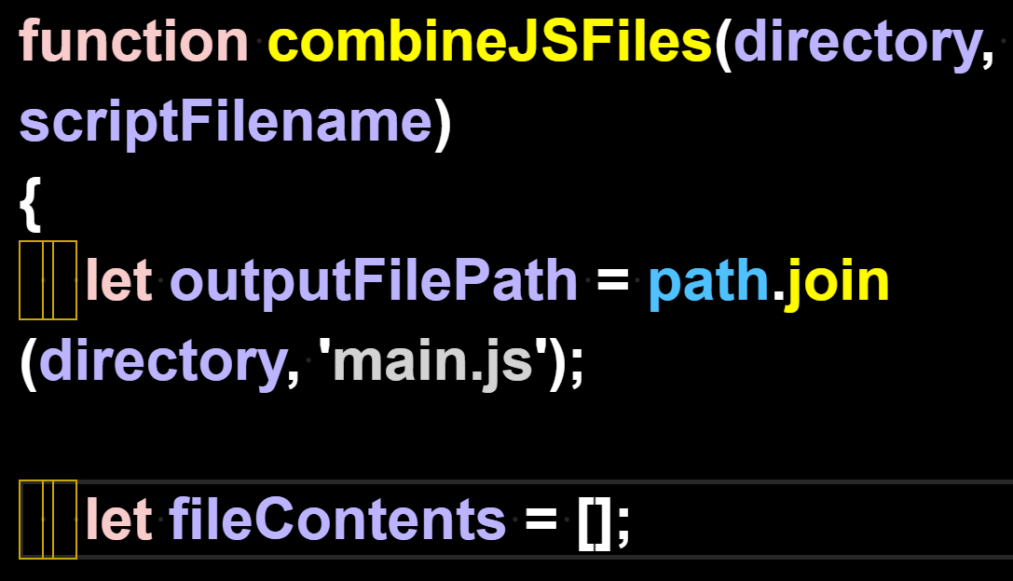

We can't leave those junk characters in the code, so we remove them with find/replace.

We Find 1 of the spaces.
We Replace All with the 1 space that we typed. This gets rid of the junk characters in the code.

We highlight 1 space with our mouse arrow:
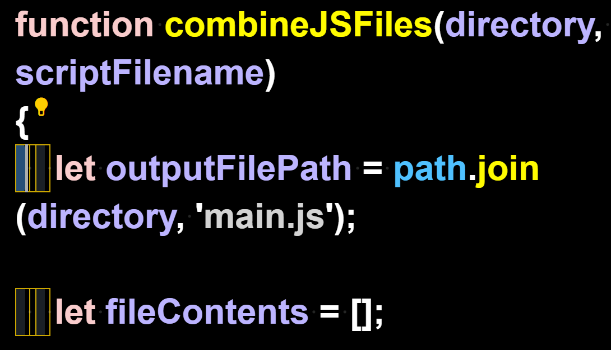
We press Control + H to open the Find/Replace feature and Replace All with our own Space
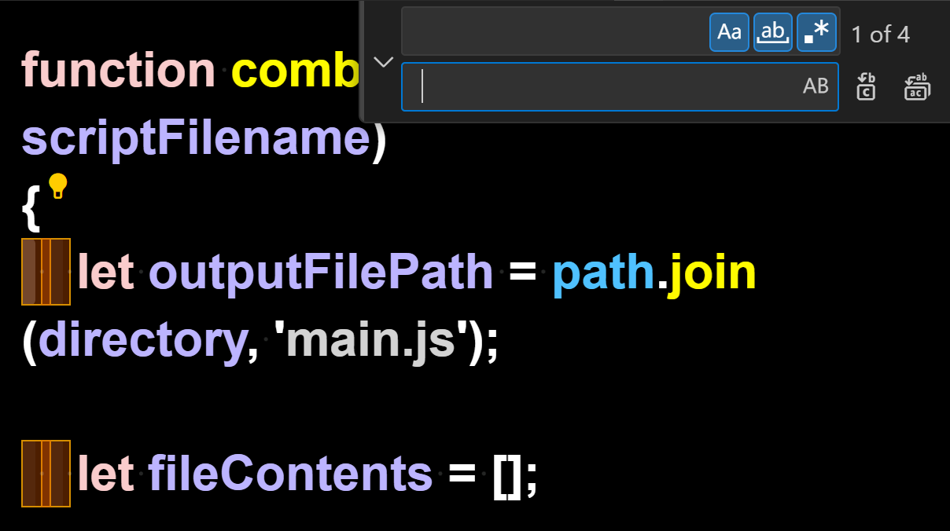

Here we see that the Find/Replace All has replaced the junk characters

with our working spaces instead:
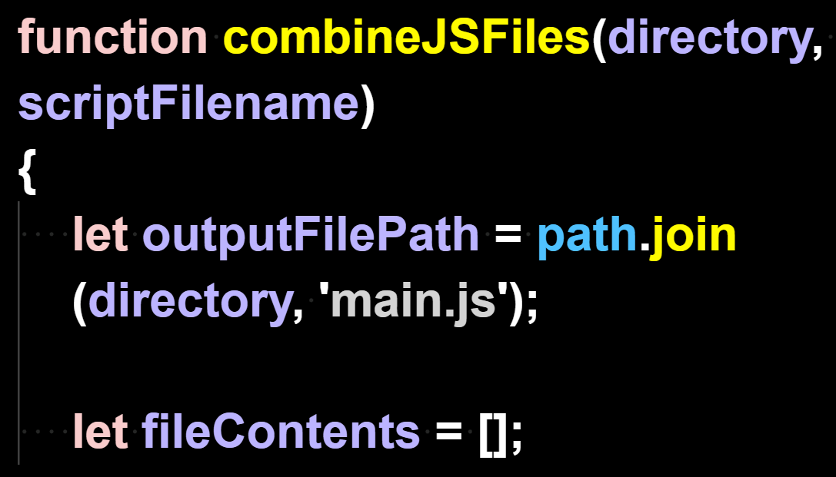

Now that the code
has no junk characters,
it can run.
How to Combine
.js files
into one
main.js file
using
Command
Prompt

Version for when we have only ONE folder of .js files that we want to combine.

// HowToCombineJSFilesOneFolder.js

First, we add two new lines at the end of every script. This way they will later combine nicely with a line break in between each script.

We open our js folder.
In our js project folder, we type
cmd
in the address bar of the folder and then
press enter

This opens our js folder in the Command prompt

We type in the words
copy *.js main.js
and then press enter

This creates a new file that is named main.js
This new file contains all .js files in ONE file.
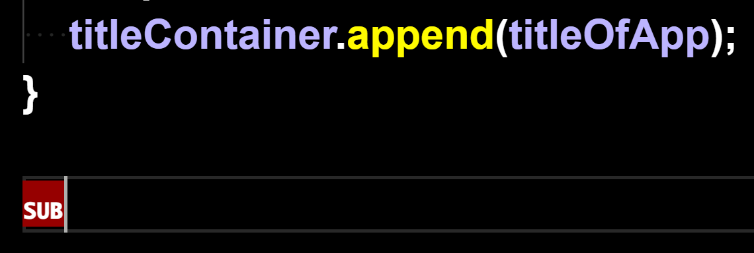
But, there is a junk character at the end of the main.js script that we have to delete. In VSCode the character might be called SUB
We remove this junk SUB character and the code will now run.
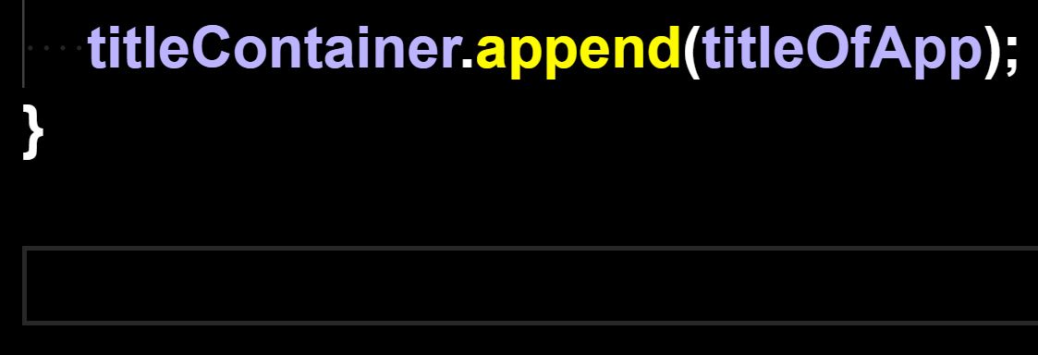
As we can see, the junk character is removed.

<!-- Now, in our html code, we can type -->
<script src = 'main.js'></script>

This makes it much easier to upload our js code to our website.
How to Combine
.js files
into one
main.js file
using
Command
Prompt

Version for when we have js scripts in subfolders in our js project folder, that we want to combine.
// HowToCombineJSFiles.js
TUTORIAL:
How to Combine all .js files in all folders that are in our js folder.

Getting things ready:
We should add two new lines at the end every script. This way they will combine nicely with a line break in between each script.

Step One: Open our js folder

Step Two: Type in the address bar of the js folder, cmd, press Enter

This opens our js folder in the command prompt

Step Three: Type the command shown below in the command prompt and then press Enter

for /r "%CD%" %i in (*.js) do type "%i" >> main.js

Now we have a newly created .js file named main.js that has all of our js files included into one file.

This makes it easy to upload our application and easy to find out how many lines of code our project is.

To use our main.js file, we include it in our html file code:
<script src = 'js/main.js'></script>
Happy Scripting :-)
How to Combine
.js files
into one
main.js file
using
a batch file

Version for when we have js scripts in subfolders in our js project folder, that we want to combine.
// HowToCombineJSFilesUsingBatFile.js

We can combine all of the .js files
that are located in our js folder
into one main.js file, using either:
The Command Prompt Method
or
The .bat File Method

The .bat file method is very easy.
We double click the bat file, which is located in our js folder, and it will make a main.js file, which includes all .js files in the js folder, including all .js files in all subdirectories of our js folder.

This is a very easy way to combine our .js files, because we can double click the .bat file anytime, and it will again generate the main.js file, which includes all .js files in the js folder, including all .js files in all subdirectories of our js folder. This makes uploading our application online much easier.

Happy Scripting :-)

:: Topalian_Combine_JS_Files.bat

:: This .bat File Combines All .js files in all folders of our project folder, into one main.js file.

:: To activate this .bat file, we double click the .bat file, while it is located in our js folder.

@echo off
:: set the output file name
set "output=main.js"

:: clear existing output file
type nul > "%output%"

:: loop through all JavaScript files in subdirectories
for /r %%i in (*.js) do (
:: append the content of each file to the output file
type "%%i" >> "%output%"
)

echo "JavaScript files combined into %output% successfully."

How to Combine
.js files
into one
main.js file
using
Node.js

This version will successfully combine a single folder of js files.
It also works to combine js files in all subdirectories.
// Topalian_Combine_JS_Files.js

let fs = require('fs');
let path = require('path');

function combineJSFiles(directory, scriptFilename)
{
let outputFilePath = path.join(directory, 'main.js');

let fileContents = [];

function traverseFolder(folder)
{
let files = fs.readdirSync(folder);

for (let i = 0; i < files.length; i++)
{
let file = files[i];

let filePath = path.join(folder, file);

let stats = fs.statSync(filePath);

if (stats.isDirectory())
{
traverseFolder(filePath);
}
else if (path.extname(filePath) === '.js')
{
let content = fs.readFileSync(filePath, 'utf8');
// check if file is not script file itself
if (filePath !== scriptFilename)
{
fileContents.push(content);
}
}
}
}

traverseFolder(directory);

fs.writeFileSync(outputFilePath, fileContents.join('\n'), 'utf8');

console.log(`Combined ${fileContents.length} .js files into ${outputFilePath}`);
}

// get current directory of script
let currentDirectory = process.cwd();

// get filename of script
let scriptFilename = __filename;

combineJSFiles(currentDirectory, scriptFilename);

How to Combine
.js files
into one
main.js file
using
Python

This version will successfully combine a single folder of js files.
It also works to combine js files in all subdirectories.
# Topalian_Combine_JS_Files.py

import os

def combineJSFiles(directory, scriptFileName):
outputFilePath = os.path.join(directory, 'main.js')
fileContents = []

def traverseFolder(folder):
for root, dirs, files in os.walk(folder):
for file in files:
filePath = os.path.join(root, file)
if filePath != scriptFileName and filePath.endswith('.js'):
with open(filePath, 'r', encoding='utf-8') as f:
fileContents.append(f.read())

traverseFolder(directory)

with open(outputFilePath, 'w', encoding='utf-8') as f:
f.write('\n'.join(fileContents))
print(f"Combined {len(fileContents)} .js files into {outputFilePath}")

# get current directory of script
currentDirectory = os.path.dirname(os.path.abspath(__file__))

# get filename of script
scriptFileName = os.path.abspath(__file__)

combineJSFiles(currentDirectory, scriptFileName)

What other file types can we combine?

We have combined .js files in this book, but we might choose to instead combine:

.py or .html or .txt

This is very useful for book making.

In each of the scripts shown in this book, we can manually change the parts where it says .js, with .py, if we wanted to, for instance, copy all .py files into one main.py file.

We can do the same thing for .html files, where we change the file type it will be combining to .html and it will combine all .html files into one main.html file.

We add two line breaks at the end of all files, so that there is space between files, when they are combined.

Remember too, that not all file types will combine, but the ones above will.

The original files are not changed. The content from the original files is only copied from.

True Artificial Intelligence System
Tautology
1111
Contra-
-diction
0000
XOR
0110
XNOR
1001
AND
0001
NAND
1110
OR
0111
NOR
1000
MI
1101
MNI
0010
LP
0011
LC
1100
RP
0101
RC
1010
CI
1011
CNI
0100
16-Gon
For More Tutorials:

GitHub.com/ChristopherTopalian
GitHub.com/ChristopherAndrewTopalian
Sites.google.com/view/CollegeOfScripting
CollegeOfScripting.weebly.com
CollegeOfScripting.wordpress.com
Youtube.com/ScriptingCollege
Twitter.com/CollegeOfScript
Rumble.com/user/CollegeOfScripting
Dedicated to God the Father
This book is created by the
College of Scripting Music & Science.
Always remember, that each time you write a script with a pencil and paper, it becomes imprinted so deeply in memory that the material and methods are learned extremely well.

When you Type the scripts, the same is true. The more you type and write out the scripts by keyboard or pencil and paper, the more you will learn programming!

Write and Type every example that you find.
Keep all of your scripts organized.
Every script that you create increases your programming abilities.
SEEING CODE, is one thing,
but WRITING CODE is another.
Write it, Type it, Speak it, See it, Dream it.
CollegeOfScripting.weebly.com

